Joint African Union Commission and OECD Development Centre meeting:
Financing Transformation: How can Sovereign Debt and Domestic Revenues Expand Fiscal Space for Productive Investment?
featuring the launch of Revenue Statistics in Africa 2026

24 November 2026 | 15:00 – 17:00 | OECD Conference Centre (Room CC2), Paris and via Zoom

At a time of tightening financing conditions and rising development needs, governments face a common challenge: how to expand fiscal space while maintaining debt sustainability. The discussion is increasingly shifting from the volume of debt to its purpose, quality and developmental impact.
This policy dialogue will take stock of new evidence from the forthcoming edition of Africa's Development Dynamics 2026: Managing Debt for Transformation and launch the publication Revenue Statistics in Africa 2026. How can countries strengthen domestic resource mobilisation, improve the quality of public investment, and use sovereign borrowing more effectively to support productive transformation? This dialogue is part of regular reflection meetings benefiting from insights into financing for development, bringing together experts involved in both reports.
Africa’s Development Dynamics (AfDD) is the flagship report on Africa’s economic development produced by the African Union Commission and the OECD Development Centre, with financial support from the European Union, Germany, Portugal, and Italy. It provides decision makers and policymakers with evidence-based analysis and harmonised data on Africa’s productive transformation and regional integration. AfDD 2026 addresses the question: “How can African countries manage sovereign debt sustainably to finance productive transformation and development?”.
Revenue Statistics in Africa compiles comparable tax and non-tax revenue data between 1990 and 2024 for 39 countries in Africa, along with preliminary 2025 statistics for 33 countries. This annual report is a joint publication by the OECD Centre for Tax Policy and Administration, the OECD Development Centre, the African Union Commission and the African Tax Administration Forum, with technical support from the African Development Bank and the Exchange and Reflection Forum for Tax Administration Leaders (CREDAF).
Guiding questions:
- How can African and other developing economies align sovereign borrowing more effectively with productive transformation and economic diversification?
- What policies are most effective in expanding fiscal space through stronger domestic resource mobilisation?
- How can governments strengthen the link between borrowing, resource mobilisation and future growth?
- What lessons can African and other developing economies share on balancing stronger debt sustainability, domestic resource mobilisation and development ambitions?

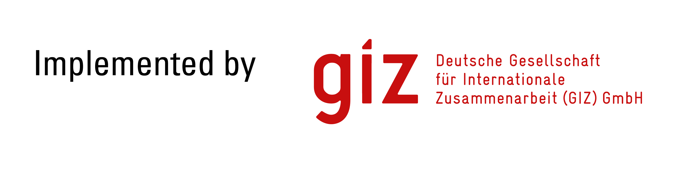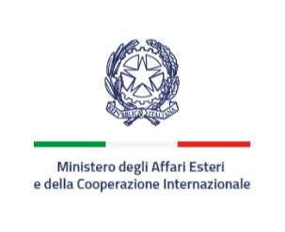In co-operation with Africa’s Development Dynamics donors and partners

Draft Agenda

15:00 – 15:10 | Welcome remarks
 | - Ragnheiður Elín Árnadóttir, Director, OECD Development Centre
15:10 – 15:20 | Managing Debt and Mobilising Revenues for Africa’s Transformation
- Arthur Minsat, Head of Unit for Africa, Regional Development Dynamics Division, OECD Development Centre
- Patrick Olomo, Head Economic Policy and Sustainable Development, Department for Economic Development, Trade, Tourism, Industry and Minerals, African Union Commission

15:20 – 15:30 | Launch presentation of Revenue Statistics in Africa 2026
 | - Alexander Pick, Head of Unit for Tax Data and Statistical Analysis, OECD Centre for Tax Policy and Administration
15:30 – 16:55 | Interactive open segment
- Fatos Koc, Head of Unit for Financial Markets, OECD Directorate for Financial and Enterprise Affairs
- Prof. Paola Subacchi, Chair in Sovereign Debt, Sciences Po
- Martin Kessler, Executive Director, Finance for Development Lab
- Sanne Zwart, Head of the Model Governance Unit, Economics Department, European Investment Bank
- Bathylle Missika, Head of the 4P - Pact for Prosperity, People and the Planet Secretariat
- Ezera Madzivanyika, Manager, Applied Research and Statistics, African Tax Administration Forum (ATAF)
- Abdul Abiad, Deputy Chief Economist, Asian Development Bank
- Noel Pérez, Acting head, Economic Development Division, Economic Commission for Latin America and the Caribbean

Moderation: Sebastián Nieto Parra, Head of the Regional Development Dynamics Division, OECD Development Centre

16:55 – 17:00 | Closing remarks
- Patrick Olomo, Head Economic Policy and Sustainable Development, Department for Economic Development, Trade, Tourism, Industry and Minerals, African Union Commission
- Federico Bonaglia, Deputy Director, OECD Development Centre

